Pelvic floor health for new moms
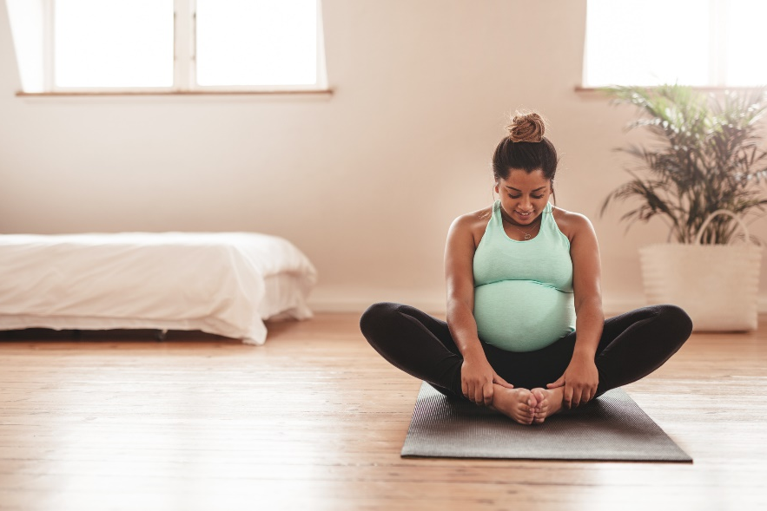
You’re a new Mom! Congratulations. Among the changes that occur when you have a baby, childbirth and pregnancy can also have an impact on your pelvic floor.
In Alberta, there are specific clinics and specialists that can help and educate on pelvic floor issues, such as bladder and bowel control and pelvic organ prolapse.
Age can have a lot to do with your pelvic floor health, especially when it comes to recovery following childbirth. The effects of having a baby and lifestyle issues can cause to changes to your pelvic floor, resulting in symptoms. That’s why it’s important to learn what you can do to prevent and address issues, for now and for the future.

What is the pelvic floor?
Your pelvic floor is at the base of your abdomen, between your legs which can be thought of as the bottom of a canister. Your abdominal muscles and bones are the back of the canister, and the top is your diaphragm, the muscle that moves your lungs up and down to help you breathe. The weight of your abdomen sits on the base of this canister, the pelvic floor. There are no bones underneath your pelvic floor, only muscles circling around it, so the pelvic floor muscles act like a sling or trampoline to support your pelvic organs. A healthy pelvic floor controls your bladder and bowels, and is important for sexual intercourse, along with lifting and carrying things by controlling the pressure inside your abdomen.
They also work with your deep abdominal, low back, and diaphragm to give you stable posture.
The large group of core muscles is called your Levator ani, which suggest there is a lifting action. Circular-shaped muscles called sphincters are around your urethra and anus. These pinch the urethra and anus closed as you do pelvic floor exercises, sometimes called Kegels.

Pregnancy and the pelvic floor
Pregnancy puts stress on your pelvic floor due to the weight of the baby along with pregnancy hormones that loosen and stretch the area. Your uterus grows and becomes heavier as your baby grows which pushes down on your pelvic floor and your bladder. Labour and the type of delivery – vaginal or cesarian (C-section) – can also affect your pelvic floor.
Swelling, pain, and even a loss of feeling or tone in your pelvic floor can occur after a vaginal delivery. During a C-section, the pregnancy hormones are still present, doubling your blood volume, while your urethra (the tube from the bladder) dilates and loses some of its tone.

Managing pelvic floor issues
Exercise and lifestyle are two of the main ways to address your pelvic floor issues. After having a baby, you may find it harder to find and use your pelvic floor muscles which is why it’s important to consider the following:
- Consult a pelvic health physiotherapist – These trained specialists can help you find these muscles and start a program.
- Contact the Rehabilitation Advice Line – They can help you get in touch with the proper resources to find out more.
- Avoid straining or pushing down when using the toilet – This can lead to incontinence (when you can’t control your bladder or bowels) and prolapse (when pelvic organs sag down). Take your time.
- Drink enough fluids to stay hydrated – Try to urinate every three to four hours, and ensure your urine is a light-yellow colour
- Eat healthy foods and get enough fibre – Eating well not only helps your internal organs to remain healthy and function optimally, being a healthy weight helps put less pressure on your pelvic floor. Seek advice from a nutritionist.
- Return to gentle movement – Everyone returns to exercise at a different time after giving birth. Walking or gently stretching can help your body get rid of extra pregnancy fluids. Talk to your healthcare provider if you have questions about exercising after having a baby.
- Avoid smoking – Smoking often causes coughing which Is hard on your pelvic floor and can irritate your bladder and rectum.
v

Wellness Articles
Alberta Health Services encourages all Albertans to live a healthy life. These weekly Wellness Articles are created by a team of healthcare professionals from AHS in collaboration with
provincial healthcare experts in Alberta and content from myhealth.alberta.ca.
Our experts ensure this information is factual, current, and written for Albertans.
From stress-relief strategies to finding balance within your life, these Wellness Articles cover a
variety of different topics designed to inspire and educate Albertans on creating a positive and
healthy lifestyle.
We welcome and encourage weekly newspapers, community newsletters and other publications
to reproduce this information free of charge. Please credit Alberta Health Services or the identified
content provider.
If you would like to be added to the distribution list for these articles, please email: rebecca.johnson2@ahs.ca. You will receive a monthly email containing articles for the
upcoming four weeks.

